Department of Computer Science and Engineering
Course Code & Name | CSA06 – Design and Analysis of Algorithms
Assessment | CO1 – Assessment Tool 1: IT Application-Based Problem Solving – Scalability Audit of an E-Commerce Platform
Course Outcome Assessed | Determine algorithm efficiency using asymptotic notations and mathematical techniques including Master Theorem and substitution method.
Duration | 3 Days
Mode | Individual
Student Reg. No. | 192421166
Student Name | DHILIBAN M

Instructions: Answer all parts. Show the basic operation, every step of each derivation and the final asymptotic result, and interpret what each result means for the platform. Assume the platform’s servers execute 10⁸ basic operations per second.
IT APPLICATION-BASED PROBLEM
Scenario – Scalability Audit of “ShopSphere”, an Online Shopping Platform: ShopSphere is a growing e-commerce platform whose product catalogue currently holds n = 100,000 products and is expected to reach n = 1,000,000 within a year. Before the expansion, the CTO has asked you, as the platform’s algorithm engineer, to audit five back-end modules, predict how each will behave as n grows, and recommend which modules must be redesigned. The modules are described below.
Module M1 – Duplicate-Listing Detector: Sellers sometimes upload the same product twice. Every night, the following routine compares every product with every later product.
FOR i ← 0 TO n − 2 DO
FOR j ← i + 1 TO n − 1 DO
IF Product[i].title = Product[j].title AND Product[i].seller = Product[j].seller THEN
MarkDuplicate(j)
END IF
END FOR
END FOR

Module M2 – API Rate Limiter: The public API audits request windows of doubling size using the routine below. A team member claims that it is Θ(n log n) because the outer loop runs about log n times and the inner loop runs up to n times.
i ← 1
WHILE i < n DO
FOR j ← 0 TO i − 1 DO
Audit(Request[j]) // basic operation
END FOR
i ← i × 2
END WHILE

Module M3 – Product Search: Two versions exist. Version S1 scans the unsorted catalogue sequentially until the product is found. Version S2 searches a sorted product index by comparing the key with the middle entry and discarding half the index after each comparison; its comparison count satisfies T(n) = T(n/2) + 1, T(1) = 1.
Module M4 – Recommendation Engine: The engine splits the customer–product data into four parts of size n/2 (because of replicated partitions) and merges the partial results in linear time: T(n) = 4T(n/2) + n. A proposed redesign removes the replication, giving T(n) = 2T(n/2) + n.
Module M5 – Sales Analytics Engine: The analytics engine splits the sales data into halves recursively and sorts the records by revenue at every level, giving T(n) = 2T(n/2) + n log n. Separately, profiling shows that the nightly report generator performs f(n) = 3n² + 10n log₂ n + 50 operations.
(a) Understand the Problem: For each of the five modules, identify the input size and the basic operation that dominates the running time, explain where it occurs, and state how you expect its execution count to grow as n increases. Justify each choice briefly.
(b) Analyse the Iterative Modules: For M1, derive the exact number of comparisons as a function of n and state the time and space complexity. For M2, derive the exact number of Audit operations, decide whether the team member’s Θ(n log n) claim is correct and give the tight bound. Verify your M2 result for n = 1,024.
(c) Solve a Recurrence by Substitution: Solve the recurrence for search version S2 using backward substitution, showing every intermediate step, and derive the exact closed form. State the time complexity and the space complexity of both an iterative and a recursive implementation.
(d) Apply the Master Theorem: For M4, apply the Master Theorem to both the current design and the proposed redesign, clearly identifying a, b, f(n), n^(log_b a) and the case used, and explain what happens to the running time when the data doubles. For M5, determine whether any of the three standard cases applies to T(n) = 2T(n/2) + n log n; if not, derive the complexity using the extended Master Theorem or a recursion tree.
(e) Analyse Best, Average and Worst Cases: For search versions S1 and S2, identify the input condition that produces the best, average and worst case and give the number of comparisons in each. For S1, derive the average number of comparisons when the probability that the searched product exists is p, and evaluate it for n = 1,000,000 and p = 0.5.
(f) Prove an Asymptotic Bound: Using the formal definitions, prove that the report generator’s cost f(n) = 3n² + 10n log₂ n + 50 is Θ(n²) by finding constants c₁, c₂ and n₀, and show that f(n) is not O(n).
(g) Scalability Decision: Estimate the number of basic operations and the running time of M1, M2, S2, M4 (both designs) and M5 for n = 1,000,000. Identify the modules that will fail to meet a nightly processing window of 10 minutes, and recommend, with justification, which modules must be redesigned and how.

Rubrics – Application-Based Question
Criteria | Weightage (%) | Level 4 – Exemplary | Level 3 – Proficient | Level 2 – Developing | Level 1 – Beginning
Understanding of Problem Context | 20 | Clearly understands the problem and accurately identifies all requirements | Good understanding with minor gaps | Basic understanding; some requirements unclear | Poor understanding or misinterpretation of the problem
Application of Concepts | 30 | Accurately applies appropriate concepts to solve complex problems | Applies relevant concepts correctly with minor errors | Applies basic concepts with limited accuracy | Fails to apply appropriate concepts
Problem-Solving Approach | 20 | Logical, well-structured, and efficient approach | Mostly logical approach with minor gaps | Basic approach with some inconsistencies | Illogical or unclear approach
Accuracy of Solution | 20 | Completely correct solution with proper justification | Mostly correct with minor errors | Partially correct solution | Incorrect or incomplete solution
Clarity | 10 | Clear, well-organized, and properly explained solution | Understandable with minor clarity issues | Limited clarity and explanation | Poorly presented and difficult to understand
Code of Conduct
I DHILIBAN M/192421166 (Name / Reg. No.) certify that this submission is my original work and that I have adhered to the guidelines specified for this assessment. I understand that any violation of academic integrity rules will result in disciplinary action.
Signature of the Student: DHILIBAN M Date:6-10-2026

ShopSphere Scalability Audit: Complete Answers
Assumptions used throughout: the server speed is 10⁸ basic operations per second, each basic operation costs 1 unit, and logarithms are base 2.
(a) Understand the Problem
Module | Input size | Basic operation | Where it occurs | Expected growth
M1 Duplicate detector | n = number of products | Comparison of title (and seller) of Product[i] with Product[j] | The IF statement inside the inner loop | Every pair is compared, so growth is quadratic, ≈ n²/2
M2 Rate limiter | n = number of requests (window limit) | Audit(Request[j]) | Inner FOR loop | The inner loop runs 1, 2, 4, 8, … times, a geometric series, so growth is linear, about n
M3 Search (S1 and S2) | n = number of products | Comparison of the search key with a catalogue or index entry | S1: each step of the sequential scan. S2: each middle-entry comparison | S1 is linear (up to n). S2 is logarithmic (the index halves each step)
M4 Recommendation | n = size of the customer-product data | Merge step (linear work f(n) = n) plus the recursive calls | Merge at each recursion level | The current design has 4 subproblems of size n/2, so growth is quadratic. The redesign has 2 subproblems, so growth is n log n
M5 Sales analytics | n = number of sales records | Record comparison during the sort at each level (f(n) = n log n), and in the report generator the dominant term 3n² | Sorting at each recursion level | About n log² n for the analytics. The report generator grows quadratically, since the 3n² term dominates

(b) Iterative Modules
M1: exact number of comparisons
For a fixed i, the inner loop runs j = i+1 … n−1, which is (n−1−i) times.
C(n) = Σ (i = 0 to n−2) (n − 1 − i)
= (n−1) + (n−2) + … + 2 + 1
= Σ (k = 1 to n−1) k
= n(n − 1)/2 = (n² − n)/2
- Time complexity: Θ(n²). Best, average and worst case are the same, because the loops do not stop early.
- Space complexity: Θ(1) extra space, since only i, j and a few variables are used (the input itself takes O(n)).
- Meaning: doubling the catalogue makes the nightly run about 4 times slower.
M2: exact number of Audit operations
The loop variable i takes the values 1, 2, 4, …, 2^(k−1), where k = ⌈log₂ n⌉ is the number of outer iterations (the last value is still < n). For each i, Audit executes exactly i times.
A(n) = 1 + 2 + 4 + … + 2^(k−1)
= 2^k − 1 (geometric series)
= 2^⌈log₂ n⌉ − 1
For n a power of 2, A(n) = n − 1. In general, n − 1 ≤ A(n) ≤ 2n − 3.
Is the team member's claim Θ(n log n) correct? No.
The reasoning "log n outer iterations × n inner iterations" is wrong because the inner loop does not run n times in every round. It runs i times, and i is only close to n in the last round. Most rounds are much cheaper. The work is a geometric series dominated by its last term, so:
A(n) = Θ(n) (tight bound), which is better than Θ(n log n).
Verification for n = 1,024:
- i takes the values 1, 2, 4, 8, 16, 32, 64, 128, 256, 512, which is 10 outer iterations.
- Audits = 1 + 2 + 4 + 8 + 16 + 32 + 64 + 128 + 256 + 512 = 1,023 = n − 1 ✔
- The team member's formula would predict n log n = 1,024 × 10 = 10,240, which is about 10 times too high. The claim is incorrect.
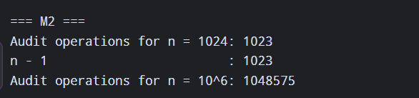

(c) Recurrence for Search S2 by Backward Substitution
T(n) = T(n/2) + 1, T(1) = 1 (take n = 2^k).
T(n) = T(n/2) + 1
= [T(n/4) + 1] + 1 = T(n/2²) + 2
= [T(n/8) + 1] + 2 = T(n/2³) + 3
...
= T(n/2^k) + k (general step, after k substitutions)
The recursion stops when n/2^k = 1, so k = log₂ n. Then:
T(n) = T(1) + log₂ n = 1 + log₂ n
For general n, the exact form is T(n) = ⌊log₂ n⌋ + 1.
Time complexity: Θ(log n).
Implementation | Time | Space
Iterative binary search | O(log n) | O(1), only low, high, mid
Recursive binary search | O(log n) | O(log n), because the call stack holds about log₂ n frames
Meaning: for n = 1,000,000, S2 needs at most 20 comparisons.
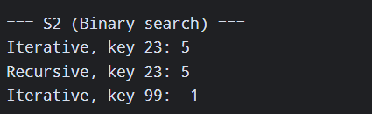
(d) Master Theorem
Master Theorem: T(n) = aT(n/b) + f(n), compare f(n) with n^(log_b a).
M4, current design: T(n) = 4T(n/2) + n
- a = 4, b = 2, f(n) = n
- n^(log_b a) = n^(log₂ 4) = n²
- f(n) = n = O(n^(2−ε)) with ε = 1, so f is polynomially smaller. Case 1 applies.
- T(n) = Θ(n²)
M4, proposed redesign: T(n) = 2T(n/2) + n
- a = 2, b = 2, f(n) = n
- n^(log₂ 2) = n¹ = n
- f(n) = Θ(n^(log_b a)) = Θ(n). Case 2 applies with k = 0.
- T(n) = Θ(n log n)
What happens when the data doubles
- Current design: T(2n)/T(n) = (2n)²/n² = 4, so the time quadruples.
- Redesign: T(2n)/T(n) = 2n·log(2n) / (n·log n) = 2(1 + 1/log n), which is just over 2. The time slightly more than doubles.
M5: T(n) = 2T(n/2) + n log n
- a = 2, b = 2, f(n) = n log n, n^(log_b a) = n
Checking the three standard cases:
- Case 1 fails: f(n) is bigger than n, not smaller.
- Case 2 (basic form) fails: f(n) = n log n is not Θ(n).
- Case 3 fails: f(n) = n log n is NOT Ω(n^(1+ε)) for any ε > 0, because log n grows slower than any n^ε. It is not polynomially larger.
So none of the three standard cases applies.
Extended Master Theorem: if f(n) = Θ(n^(log_b a) · log^k n) with k ≥ 0, then T(n) = Θ(n^(log_b a) · log^(k+1) n). Here f(n) = n · log¹ n, so k = 1:
T(n) = Θ(n log² n)
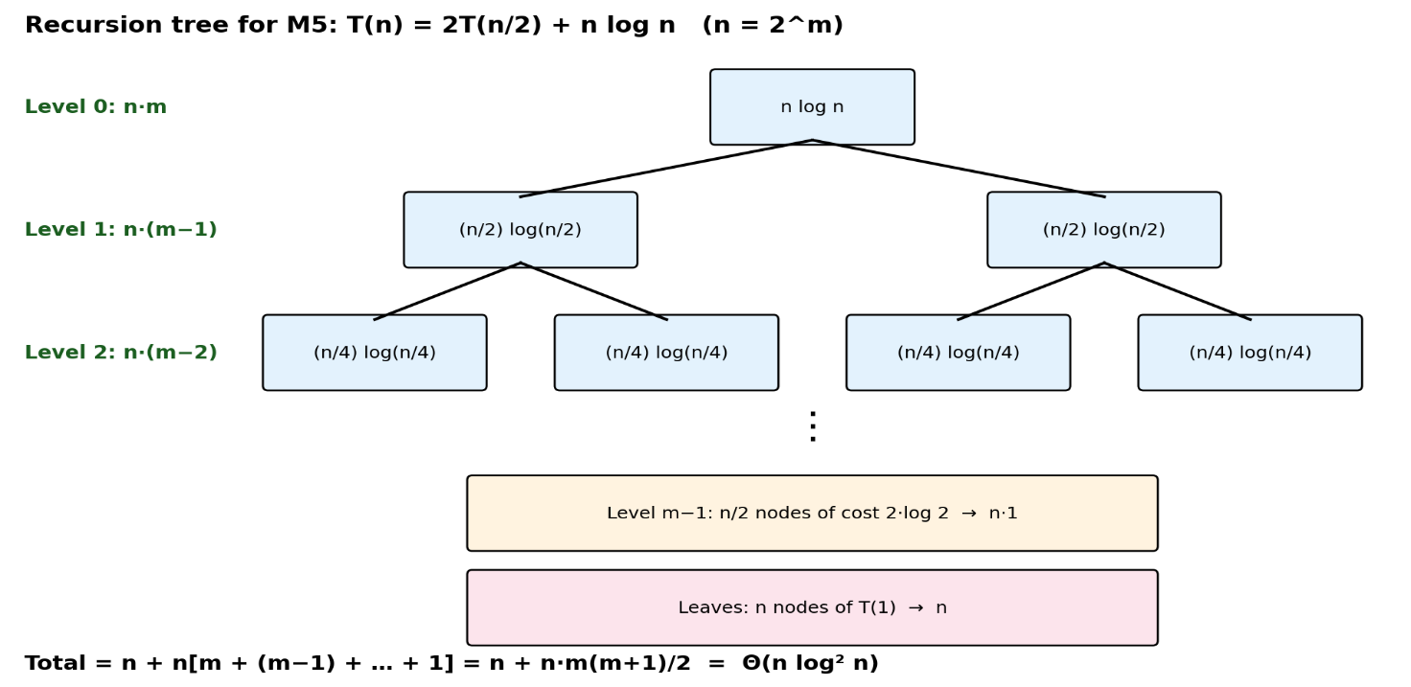(e) Best, Average and Worst Case
S1: sequential search
Case | Condition | Comparisons
Best | Product is the first element | 1
Worst | Product is the last element, or not present | n
Average | Depends on p (derived below) | See below
Average for S1: let p = probability that the product is present.
- If present (probability p), it is equally likely to be at any position i = 1…n, each with probability 1/n and cost i. The expected cost is (1/n)(1 + 2 + … + n) = (n+1)/2.
- If absent (probability 1−p), all n entries are compared, so the cost is n.
C_avg = p·(n+1)/2 + (1 − p)·n
For n = 1,000,000 and p = 0.5:
C_avg = 0.5 × (1,000,001/2) + 0.5 × 1,000,000
= 250,000.25 + 500,000
= 750,000.25 ≈ 750,000 comparisons
S2: binary search
Case | Condition | Comparisons
Best | Key is exactly the middle entry | 1, Θ(1)
Average | Key is found, equally likely anywhere | ≈ log₂ n − 1, Θ(log n) (≈ 19 for n = 10⁶)
Worst | Key is not present, or found in the last halving | ⌊log₂ n⌋ + 1, Θ(log n) (20 for n = 10⁶)

(f) Prove f(n) = 3n² + 10n·log₂n + 50 is Θ(n²)
Definition: f(n) = Θ(n²) if there exist c₁, c₂ > 0 and n₀ such that c₁n² ≤ f(n) ≤ c₂n² for all n ≥ n₀.
Lower bound: for n ≥ 1, 10n·log₂n ≥ 0 and 50 > 0, so
f(n) = 3n² + 10n·log₂n + 50 ≥ 3n²
Hence c₁ = 3.
Upper bound: for n ≥ 1 we have log₂n ≤ n, so n·log₂n ≤ n², and 50 ≤ 50n². Then
f(n) ≤ 3n² + 10n² + 50n² = 63n²
Hence c₂ = 63.
Result: 3n² ≤ f(n) ≤ 63n² for all n ≥ n₀ = 1. (Check at n = 1: f(1) = 3 + 0 + 50 = 53, and 3 ≤ 53 ≤ 63 ✔.) Therefore f(n) = Θ(n²). ∎
Show f(n) is NOT O(n):
Suppose f(n) = O(n). Then there exist c > 0 and n₀ such that f(n) ≤ c·n for all n ≥ n₀.
But f(n) ≥ 3n², so 3n² ≤ c·n, which gives n ≤ c/3 for all n ≥ n₀.
This is false for any n > max(n₀, c/3), since n grows without bound. This is a contradiction, so f(n) ≠ O(n). ∎
(g) Scalability Decision (n = 1,000,000)
Window limit: 10 min = 600 s, and 600 × 10⁸ = 6 × 10¹⁰ operations allowed.
Module | Operations at n = 10⁶ | Time at 10⁸ ops/s | Within 10 min?
M1 n(n−1)/2 | 4.99999 × 10¹¹ ≈ 5 × 10¹¹ | ≈ 5,000 s ≈ 83.3 min | ❌ FAILS
M2 2^20 − 1 | 1,048,575 ≈ 1.05 × 10⁶ | ≈ 0.0105 s | ✅
S2 ⌊log₂ n⌋ + 1 | 20 | ≈ 2 × 10⁻⁷ s | ✅
M4 current 2n² − n | ≈ 2 × 10¹² | ≈ 20,000 s ≈ 5.6 hours | ❌ FAILS
M4 redesign n·log₂n + n | ≈ 2.09 × 10⁷ | ≈ 0.21 s | ✅
M5 n + n·m(m+1)/2, m ≈ 19.93 | ≈ 2.1 × 10⁸ | ≈ 2.1 s | ✅
(Exact M4 solutions: current T(n) = 2n² − n, redesign T(n) = n·log₂n + n, both with T(1) = 1.)
Extra check: the report generator f(n) = 3n² + … ≈ 3 × 10¹² operations, about 30,000 s ≈ 8.3 hours. It also fails the window.
For comparison, at today's n = 100,000, M1 needs about 5 × 10⁹ operations (≈ 50 s), which is fine. It only breaks after the 10× growth, because its cost grows 100×.
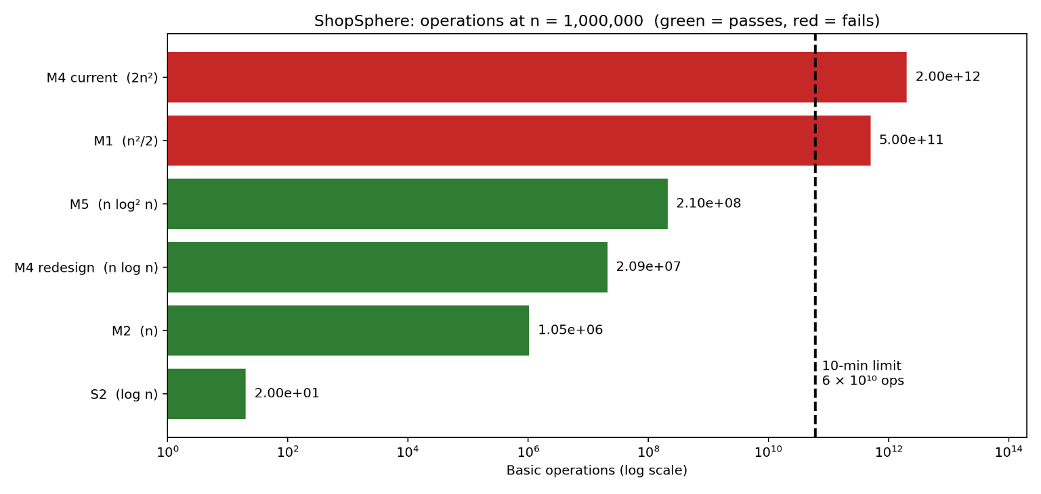
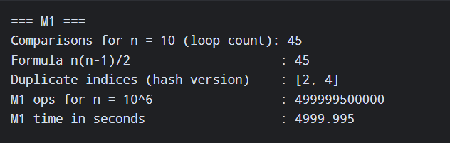

Recommendations
- M1 (must redesign): replace the all-pairs comparison with hashing. Insert each (title, seller) key into a hash set, and if the key already exists, mark it as a duplicate. This takes expected Θ(n) time, about 10⁶ operations (≈ 0.01 s) with Θ(n) extra space. A sort-based alternative (sort by (title, seller), then compare neighbours) takes Θ(n log n).
- M4 (must redesign): adopt the no-replication design, T(n) = 2T(n/2) + n = Θ(n log n). It cuts the time from about 5.6 hours to about 0.2 s, and doubling the data then only slightly more than doubles the time.
- Report generator (must redesign): the 3n² term needs a better algorithm, for example using sorting or hashing and aggregation to get O(n log n).
- M2, S2, M5 (keep): they run in well under 10 minutes. For M5, a cheap improvement is to sort once with merge sort instead of re-sorting at every level, which gives Θ(n log n) instead of Θ(n log² n).
- S1 (retire): it takes about 750,000 comparisons on average at n = 10⁶. Use S2 on a sorted index, or a hash index for exact-match lookups.

